# Lab 11 – Introduction to LAB VIEW

## Exercise

### Exercise 1

Make a task on labview VI , To convert Fahrenheit to Kelvin.

**Task:**

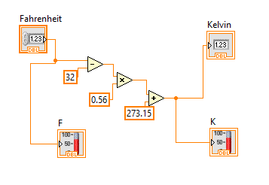

**Output:**

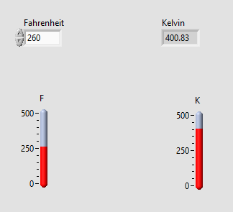

### Exercise 2

Make a task on labview VI , To convert Kelvin to Degree Celsius .

**Task:**

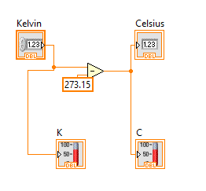

**Output:**

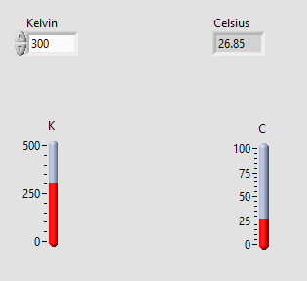

### Exercise 3

Make a task on labview VI , To convert Kelvin to Fahrenheit .

**Task:**

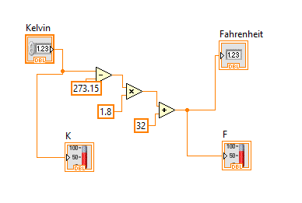

**Output:**

